VISVESVARAYA TECHNOLOGICAL UNIVERSITY

“JnanaSangama”, Belgaum -590014, Karnataka.

LAB RECORD

Bio Inspired Systems (23CS5BSBIS)
Submitted by
Chethana C (1BM23CS077)
in partial fulfillment for the award of the degree of

BACHELOR OF ENGINEERING
in
COMPUTER SCIENCE AND ENGINEERING



B.M.S. COLLEGE OF ENGINEERING
(Autonomous Institution under VTU)
BENGALURU-560019
Aug-2025 to Dec-2025

B.M.S. College of Engineering,
Bull Temple Road, Bangalore 560019
(Affiliated To Visvesvaraya Technological University, Belgaum)
Department of Computer Science and Engineering
CERTIFICATE
This is to certify that the Lab work entitled “ Bio Inspired Systems (23CS5BSBIS)” carried out by Chethana C(1BM23CS077), who is bonafide student of B.M.S. College of Engineering. It is in partial fulfillment for the award of Bachelor of Engineering in Computer Science and Engineering of the Visvesvaraya Technological University, Belgaum. The Lab report has been approved as it satisfies the academic requirements of the above mentioned subject and the work prescribed for the said degree.

Dr. Raghavendra C K  Assistant Professor  Department of CSE, BMSCE | Dr. Kavitha Sooda  Professor & HOD  Department of CSE, BMSCE

Index
Sl.  No. | Date | Experiment Title | Page No.
1 | 18/08/2025 | Genetic Algorithm for Optimization Problems
2 | 25/08/2025 | Optimization via Gene Expression Algorithms
3 | 01/09/2025 | Particle Swarm Optimization for Function Optimization
4 | 08/09/2025 | Ant Colony Optimization for the Traveling Salesman Problem
5 | 15/09/2025 | Cuckoo Search (CS)
6 | 29/09/2025 | Grey Wolf Optimizer (GWO)
7 | 13/10/2025 | Parallel Cellular Algorithms and Programs

Github Link:
https://github.com/Chethana-0711/BIS_LAB

Program 1
Implement travelling salesman problem using genetic algorithm

Algorithm:
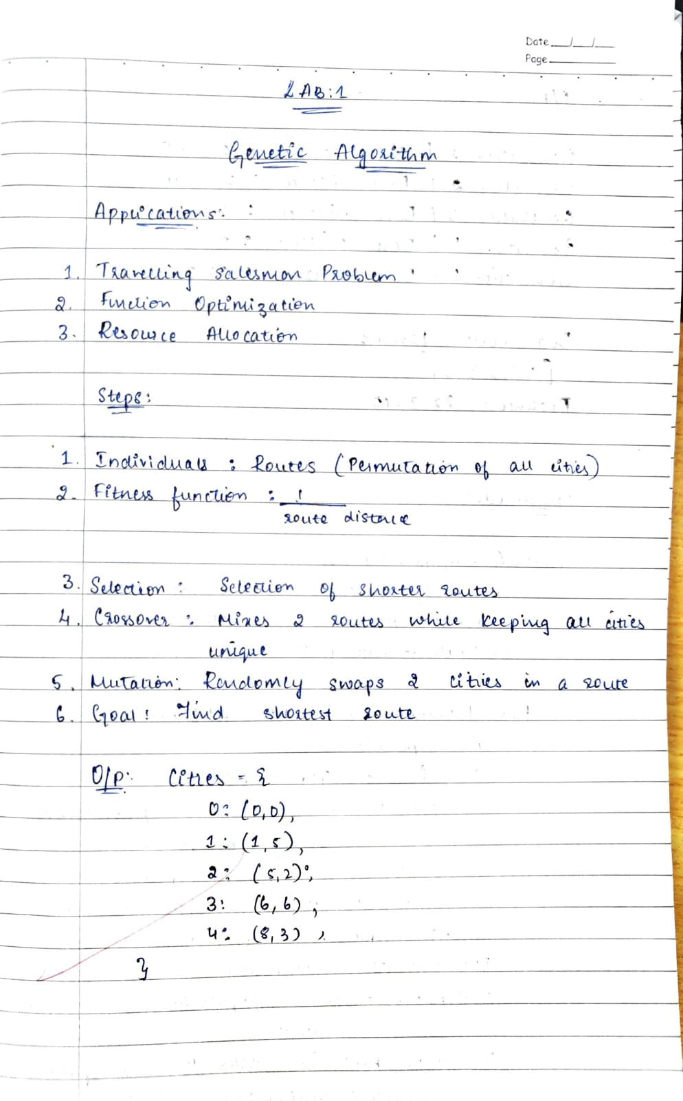
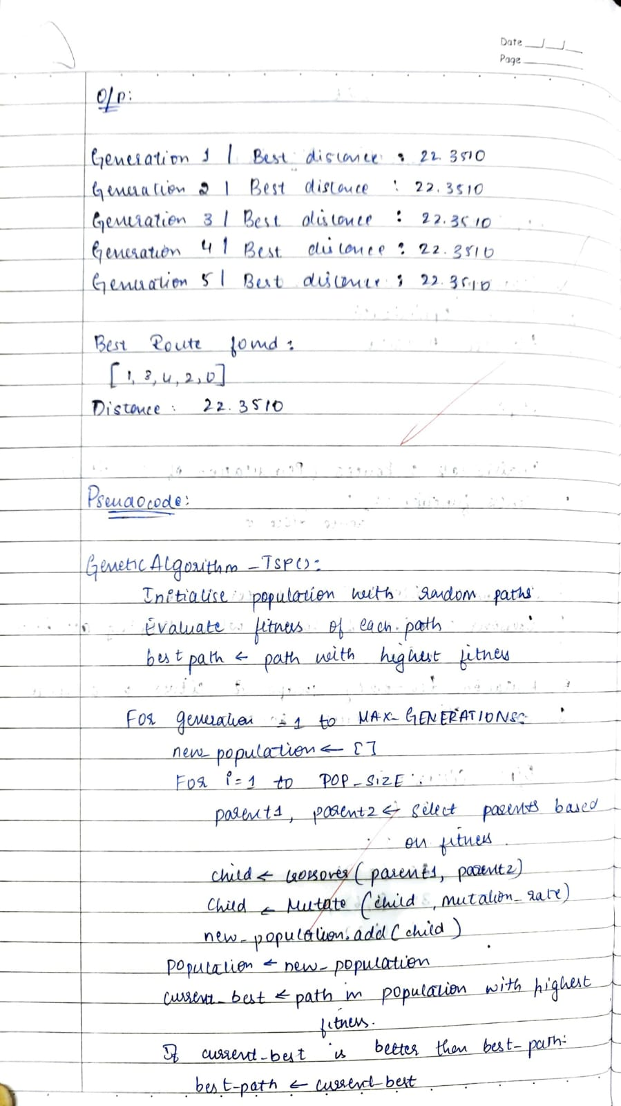
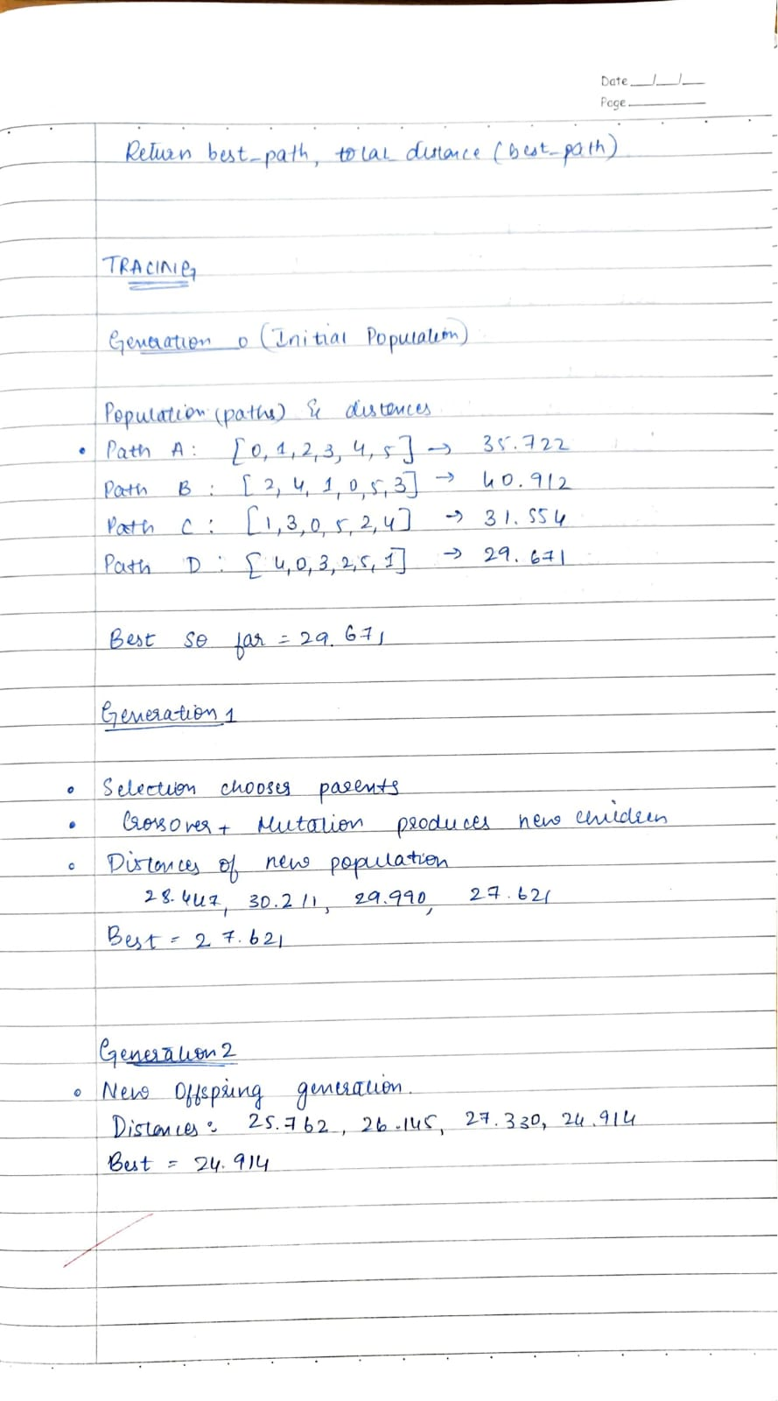
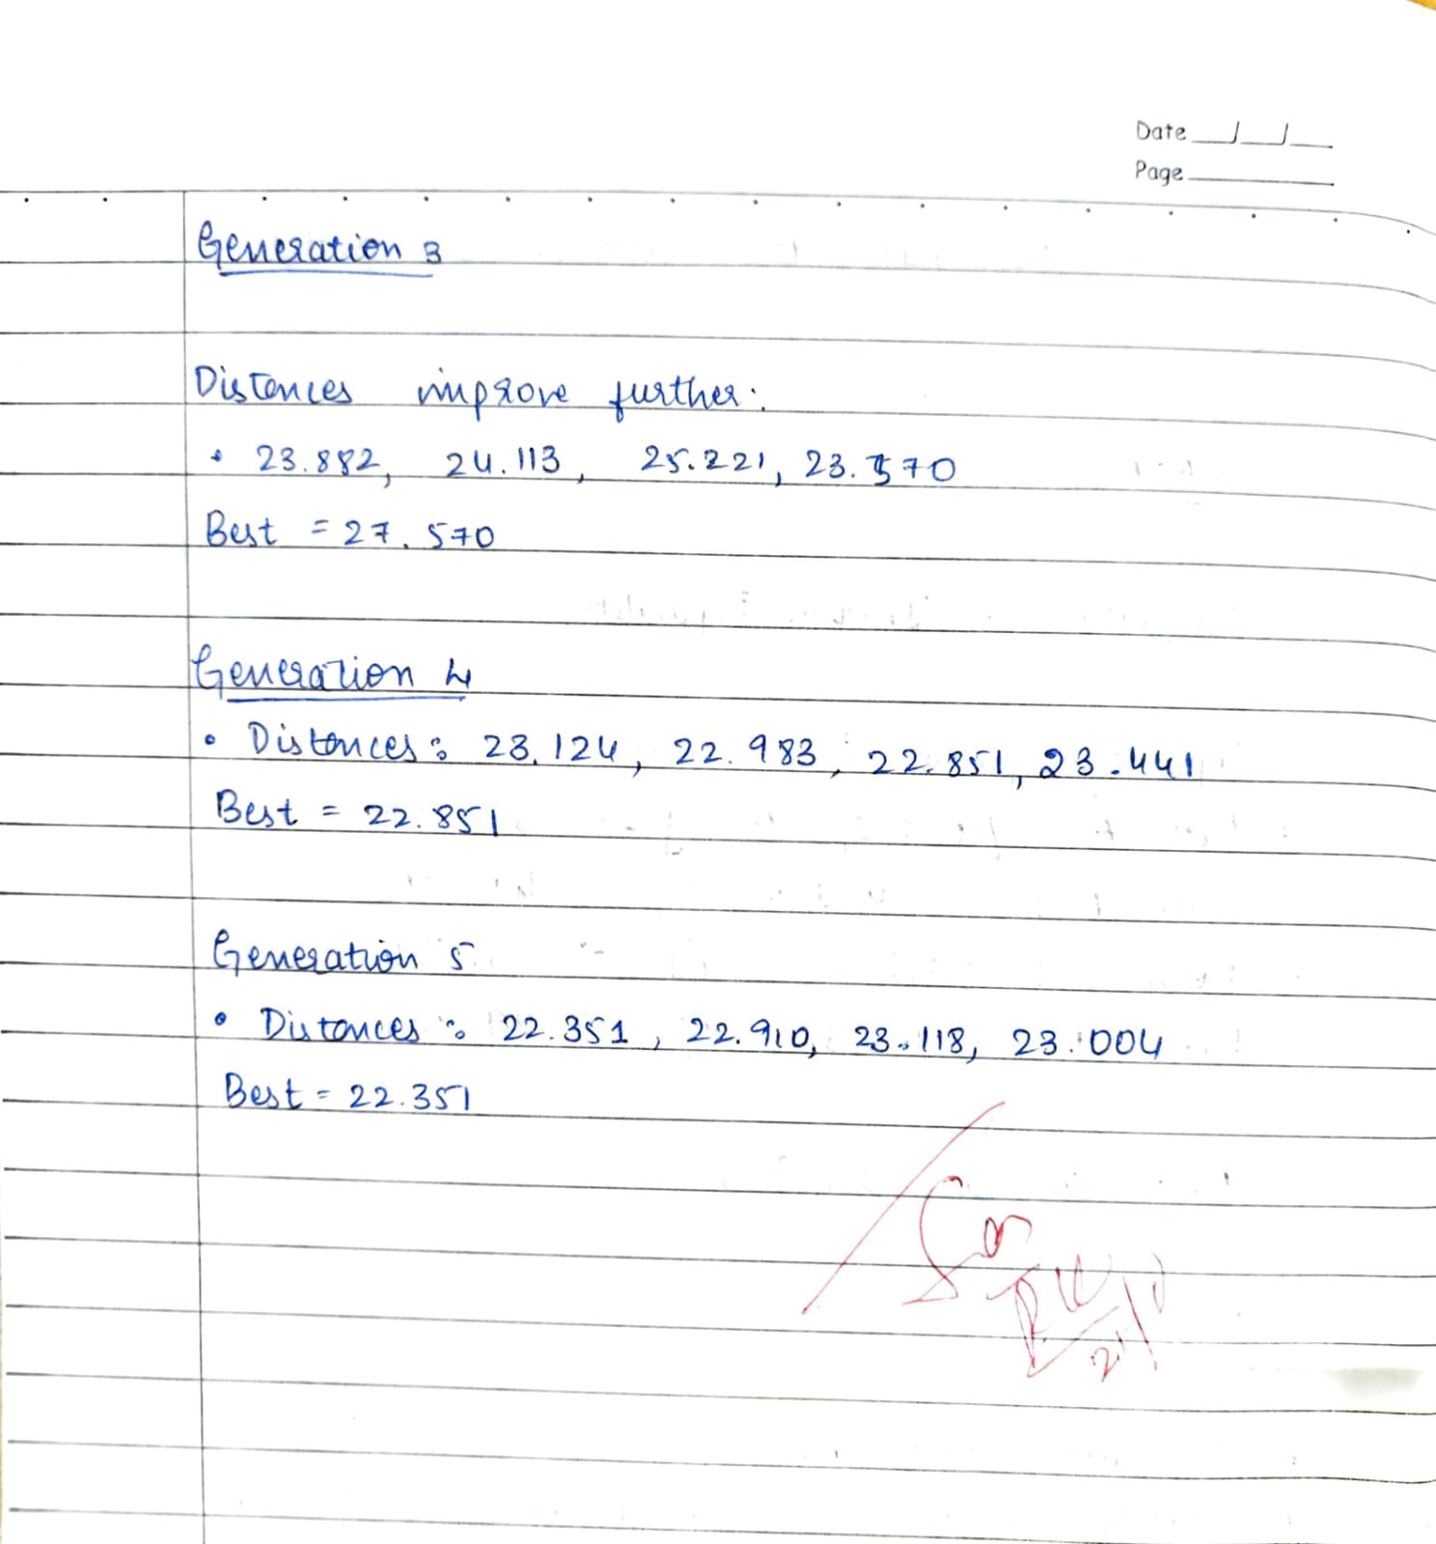

Code:
import random

def initialize_population(num_individuals, cities):
return [random.sample(cities, len(cities)) for _ in range(num_individuals)]

def calculate_distance(tour, distance_matrix):
total_distance = 0
for i in range(len(tour)):
total_distance += distance_matrix[tour[i - 1]][tour[i]] # cyclic path
return total_distance

def calculate_fitness(population, distance_matrix):
fitness_scores = []
for individual in population:
dist = calculate_distance(individual, distance_matrix)
fitness_scores.append(1 / dist)
return fitness_scores

def roulette_wheel_selection(population, fitness_scores):
total_fitness = sum(fitness_scores)
pick = random.uniform(0, total_fitness)
current = 0
for individual, fitness in zip(population, fitness_scores):
current += fitness
if current > pick:
return individual

def order_crossover(parent1, parent2):
size = len(parent1)
start, end = sorted(random.sample(range(size), 2))

offspring = [None] * size
offspring[start:end+1] = parent1[start:end+1]

pointer = 0
for city in parent2:
if city not in offspring:
while offspring[pointer] is not None:
pointer += 1
offspring[pointer] = city

return offspring

def swap_mutation(tour, mutation_rate):
if random.random() < mutation_rate:
i, j = random.sample(range(len(tour)), 2)
tour[i], tour[j] = tour[j], tour[i]
return tour

def create_new_generation(population, fitness_scores, mutation_rate):
new_population = []
population_size = len(population)

while len(new_population) < population_size:
parent1 = roulette_wheel_selection(population, fitness_scores)
parent2 = roulette_wheel_selection(population, fitness_scores)

offspring1 = order_crossover(parent1, parent2)
offspring2 = order_crossover(parent2, parent1)

offspring1 = swap_mutation(offspring1, mutation_rate)
offspring2 = swap_mutation(offspring2, mutation_rate)

new_population.append(offspring1)
if len(new_population) < population_size:
new_population.append(offspring2)

return new_population

def genetic_algorithm_tsp(cities, distance_matrix, population_size=100, mutation_rate=0.02, max_generations=500):
population = initialize_population(population_size, cities)
best_solution = None
best_distance = float('inf')

for generation in range(max_generations):
fitness_scores = calculate_fitness(population, distance_matrix)

for i, individual in enumerate(population):
dist = 1 / fitness_scores[i]
if dist < best_distance:
best_distance = dist
best_solution = individual

print(f"Generation {generation+1}: Best Distance = {best_distance:.4f}")

population = create_new_generation(population, fitness_scores, mutation_rate)

return best_solution, best_distance

if __name__ == "__main__":

cities = [0, 1, 2, 3, 4]

distance_matrix = [
[0, 2, 9, 10, 7],
[2, 0, 6, 4, 3],
[9, 6, 0, 8, 5],
[10, 4, 8, 0, 6],
[7, 3, 5, 6, 0]
]

best_tour, best_dist = genetic_algorithm_tsp(cities, distance_matrix, population_size=50, mutation_rate=0.05, max_generations=20)
print("Best Tour:", best_tour)
print("Best Distance:", best_dist)

Program 2
Gene expression algorithm for optimization

Algorithm:
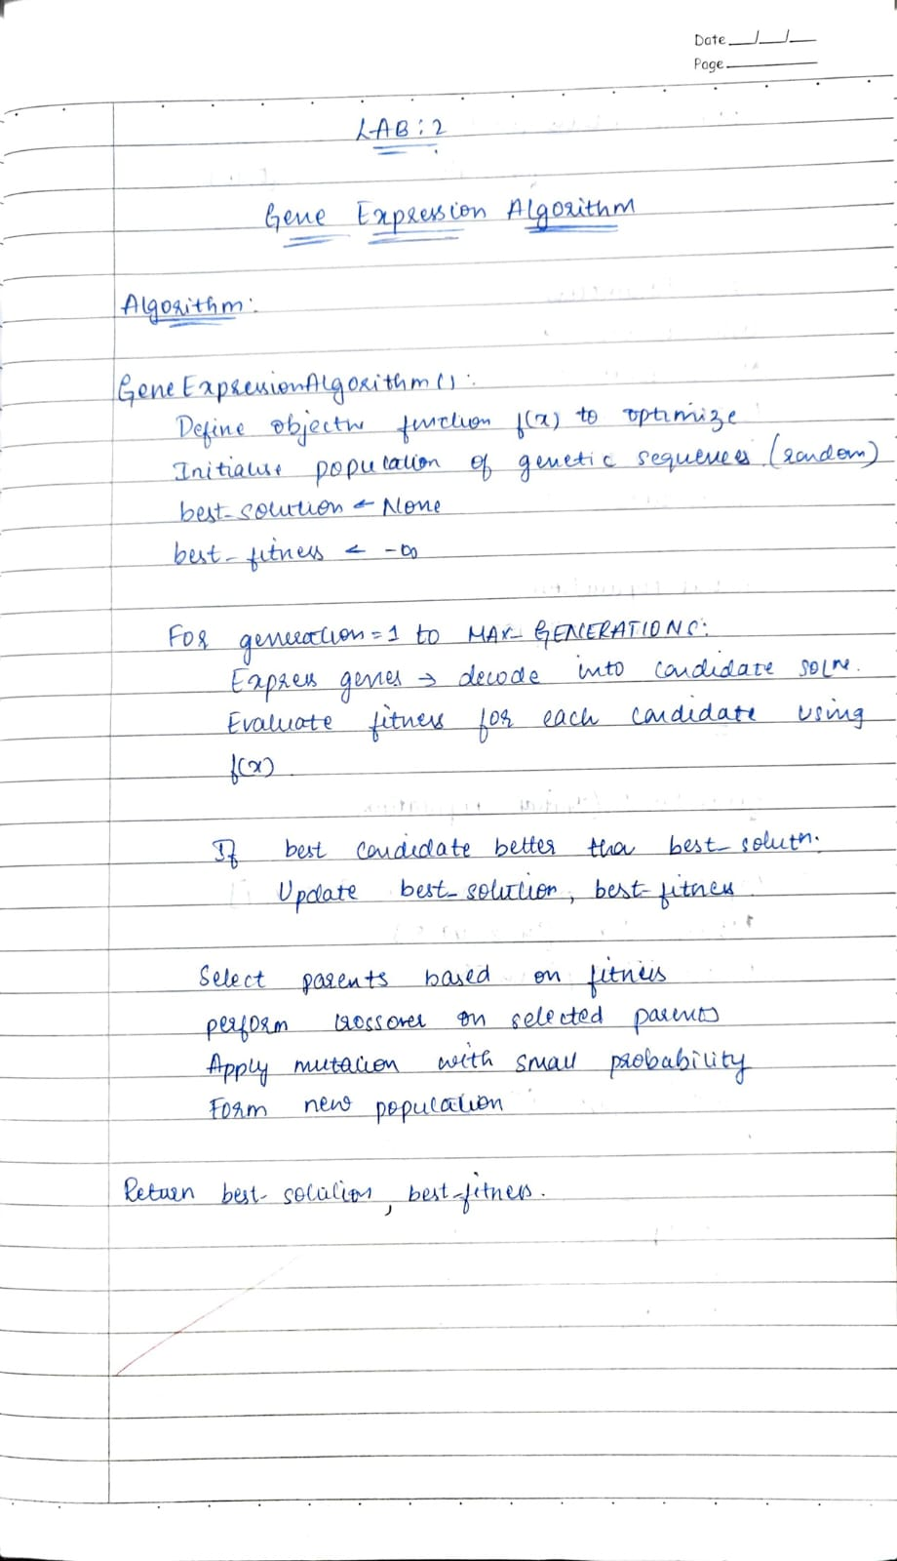
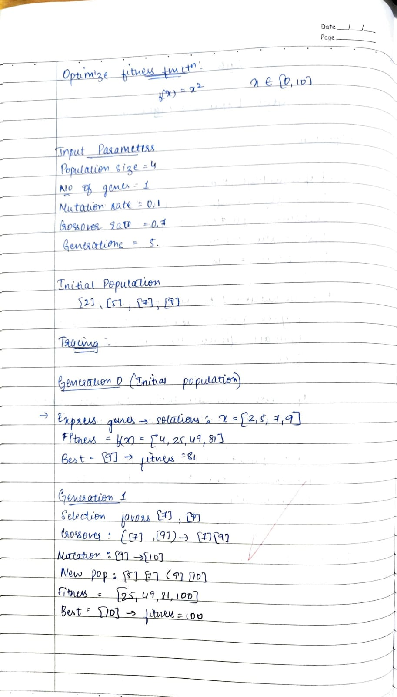
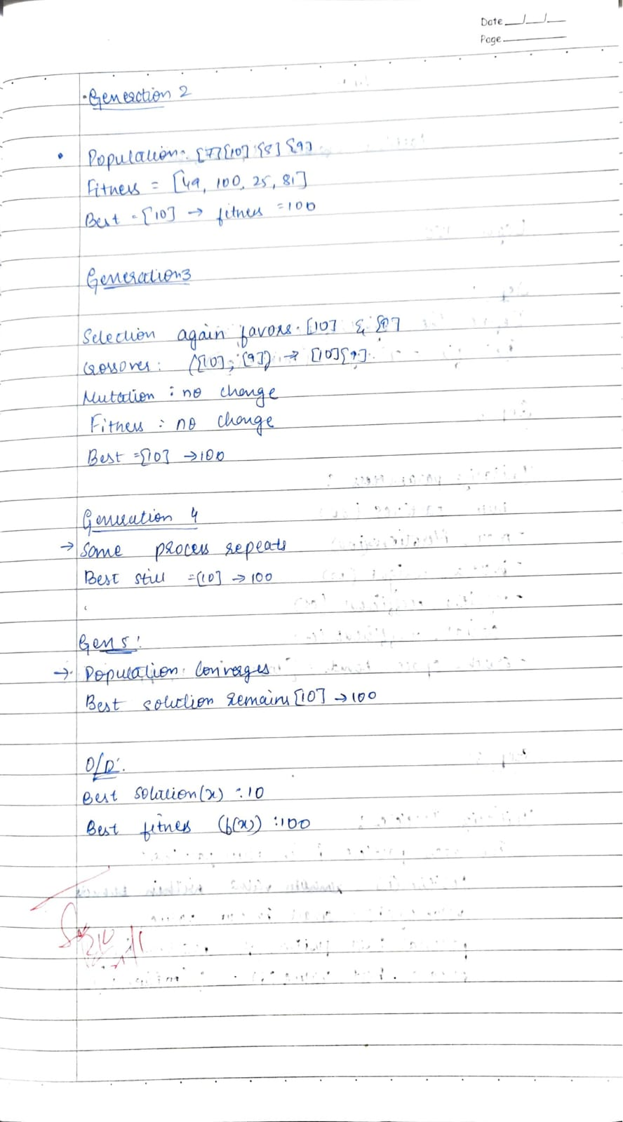
Code:
import random

def fitness_function(x):
return x ** 2

POP_SIZE = 6
GENERATIONS = 5
MUTATION_RATE = 0.2
X_RANGE = (-10, 10)

population = [random.uniform(*X_RANGE) for _ in range(POP_SIZE)]

print("Initial Population:")
print(population)

for gen in range(1, GENERATIONS + 1):

fitness = [fitness_function(x) for x in population]

sorted_pop = [x for _, x in sorted(zip(fitness, population))]
parents = sorted_pop[:2]

offspring = []
while len(offspring) < POP_SIZE - len(parents):
p1, p2 = random.sample(parents, 2)
alpha = random.random()
child = alpha * p1 + (1 - alpha) * p2
offspring.append(child)

for i in range(len(offspring)):
if random.random() < MUTATION_RATE:
offspring[i] += random.uniform(-1, 1)

population = parents + offspring

best_x = min(population, key=lambda x: fitness_function(x))
best_f = fitness_function(best_x)
print(f"\nGeneration {gen}:")
print(f"Population: {[round(x, 3) for x in population]}")
print(f"Best x = {round(best_x, 4)}, f(x) = {round(best_f, 4)}")

print("\nFinal Best Solution:")

print(f"x = {round(best_x, 4)}, f(x) = {round(best_f, 4)}")

Program 3
Implement Particle swarm optimization algorithm

Algorithm:
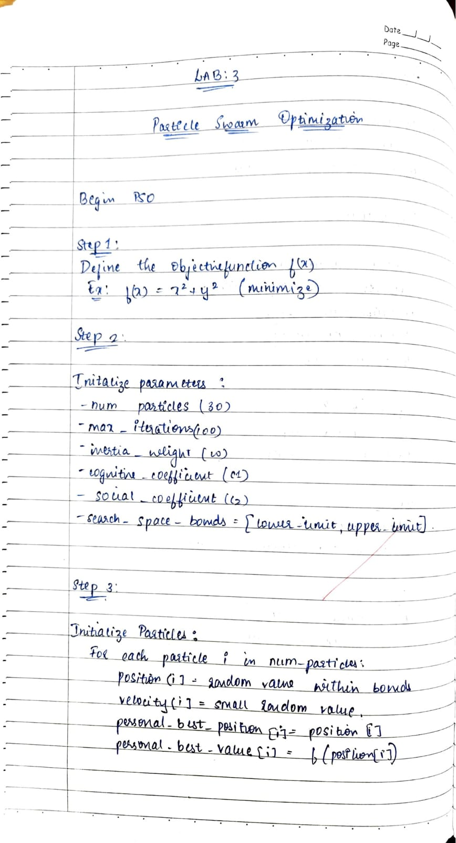
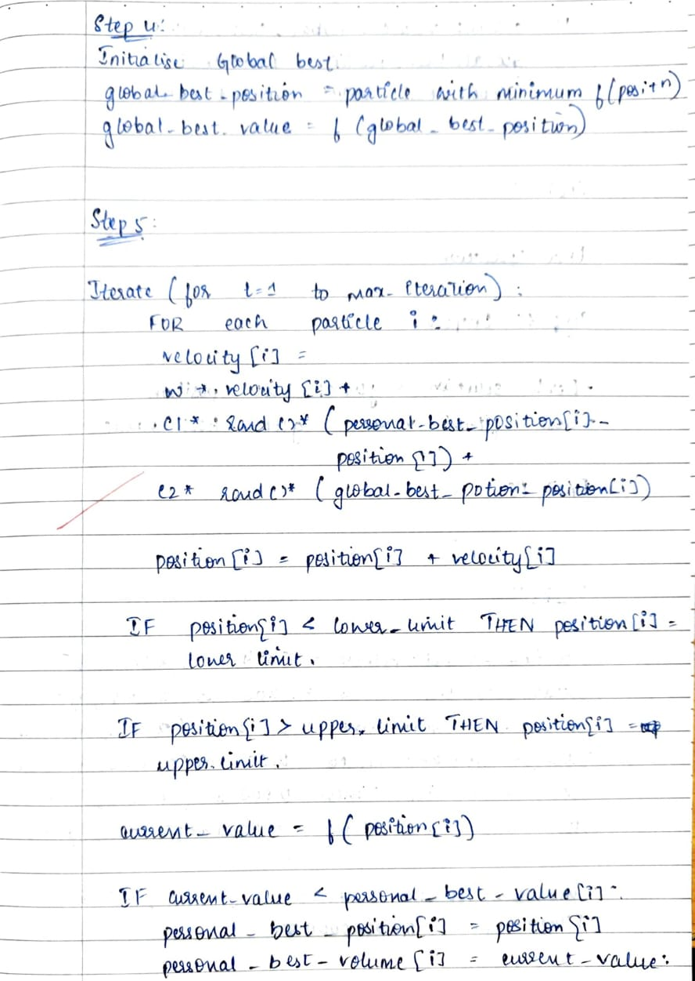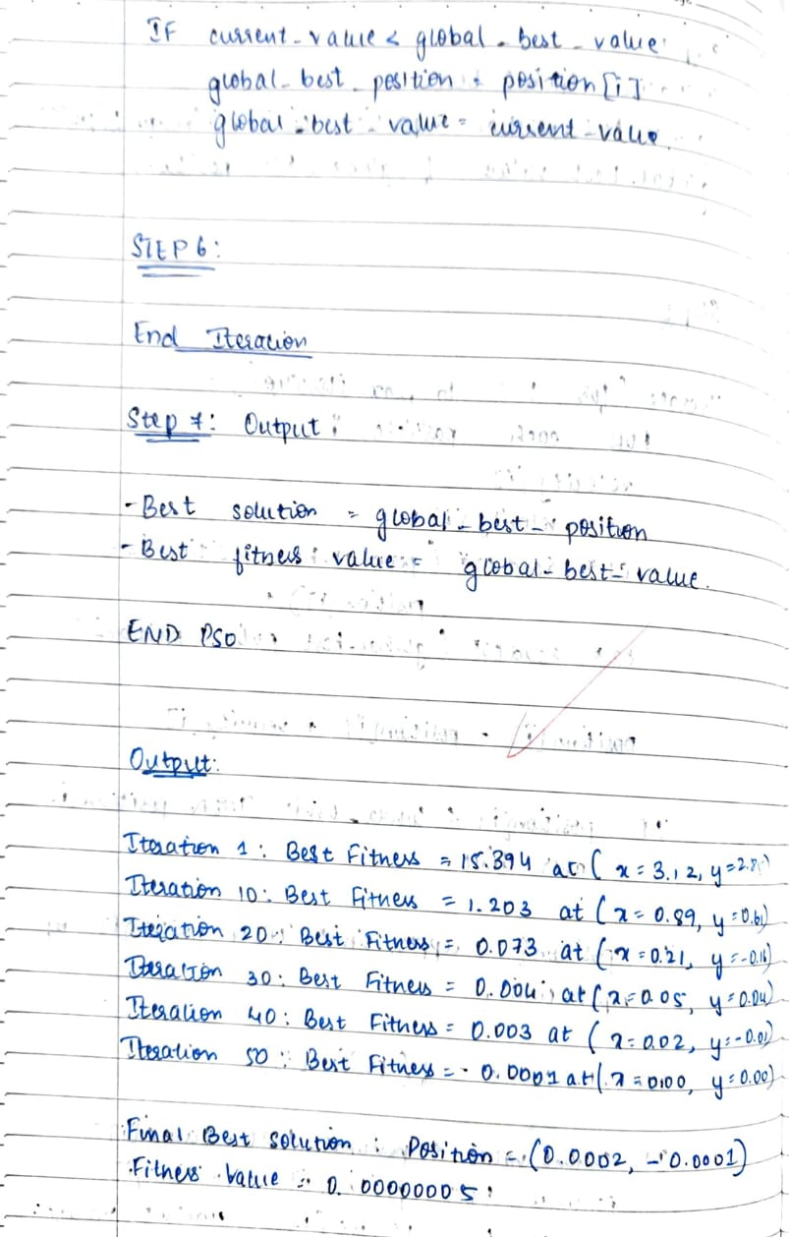
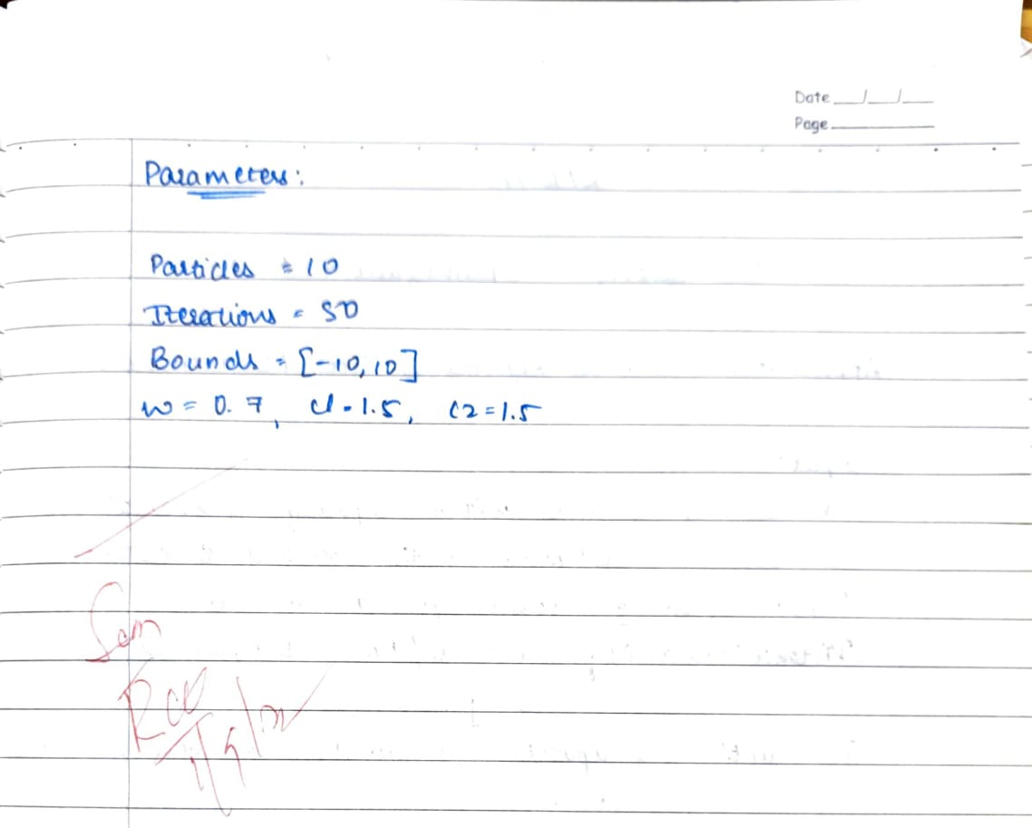
Code:
import random

def fitness_function(x, y):
return x**2 + y**2

NUM_PARTICLES = 10
ITERATIONS = 50
X_RANGE = (-10, 10)
Y_RANGE = (-10, 10)
W = 0.7
C1 = 1.5
C2 = 1.5

particles = []
for _ in range(NUM_PARTICLES):
x = random.uniform(*X_RANGE)
y = random.uniform(*Y_RANGE)
vx = random.uniform(-1, 1)
vy = random.uniform(-1, 1)
particles.append({
"x": x, "y": y,
"vx": vx, "vy": vy,
"best_x": x, "best_y": y,
"best_f": fitness_function(x, y)
})

g_best = min(particles, key=lambda p: p["best_f"])
g_best_x, g_best_y, g_best_f = g_best["x"], g_best["y"], g_best["best_f"]

for iter in range(1, ITERATIONS + 1):
for p in particles:

r1, r2 = random.random(), random.random()
p["vx"] = (W * p["vx"]
+ C1 * r1 * (p["best_x"] - p["x"])
+ C2 * r2 * (g_best_x - p["x"]))
p["vy"] = (W * p["vy"]
+ C1 * r1 * (p["best_y"] - p["y"])
+ C2 * r2 * (g_best_y - p["y"]))

p["x"] += p["vx"]
p["y"] += p["vy"]

f = fitness_function(p["x"], p["y"])

if f < p["best_f"]:
p["best_x"], p["best_y"], p["best_f"] = p["x"], p["y"], f

current_best = min(particles, key=lambda p: p["best_f"])
if current_best["best_f"] < g_best_f:
g_best_x, g_best_y, g_best_f = current_best["best_x"], current_best["best_y"], current_best["best_f"]

if iter in [1, 10, 20, 30, 40, 50]:
print(f"Iteration {iter}: Best (x, y) = ({g_best_x:.4f}, {g_best_y:.4f}), f(x, y) = {g_best_f:.6f}")

print("\nFinal Best Solution:")
print(f"Best (x, y) = ({g_best_x:.6f}, {g_best_y:.6f})")

print(f"Minimum value f(x, y) = {g_best_f:.6f}")

Program 4
Implement vehicle logistics and fleet management using ant colony optimization

Algorithm:
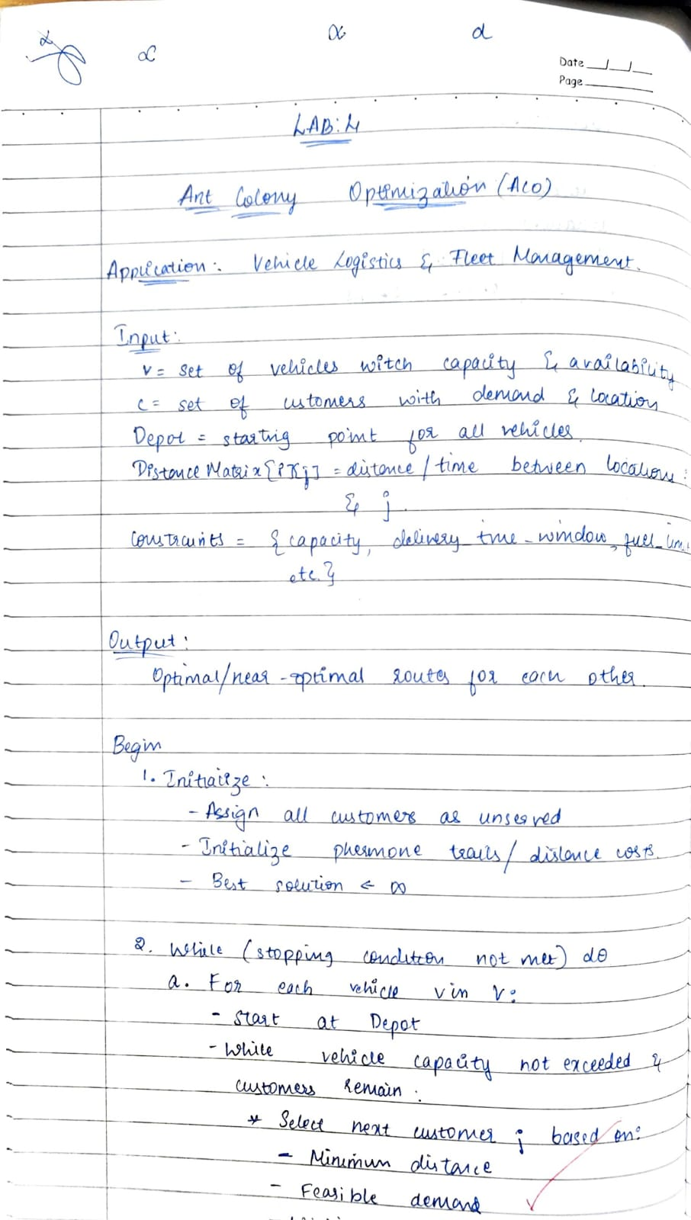
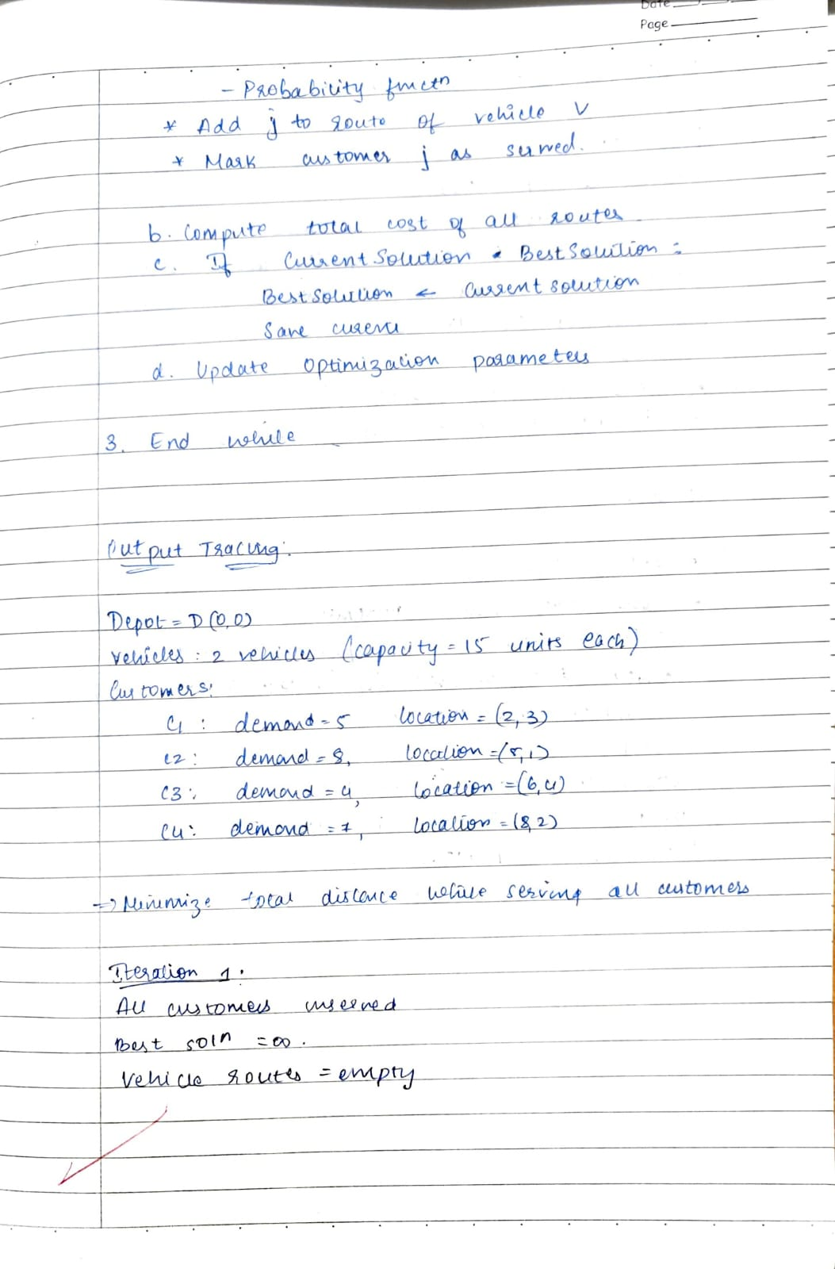
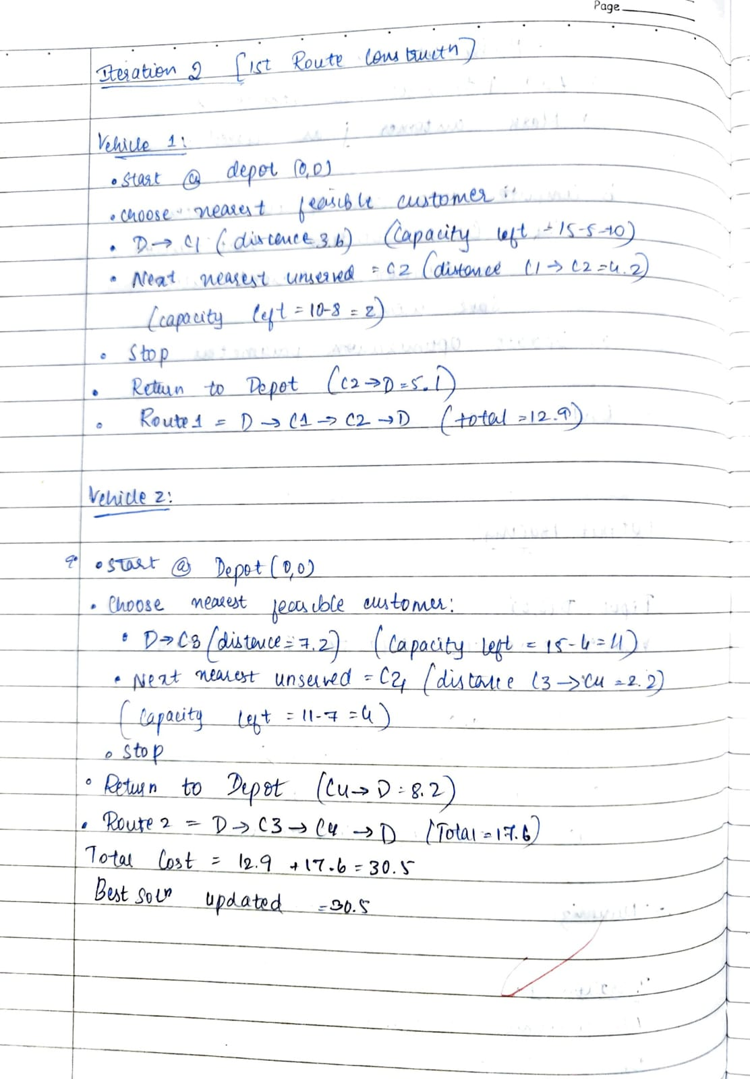
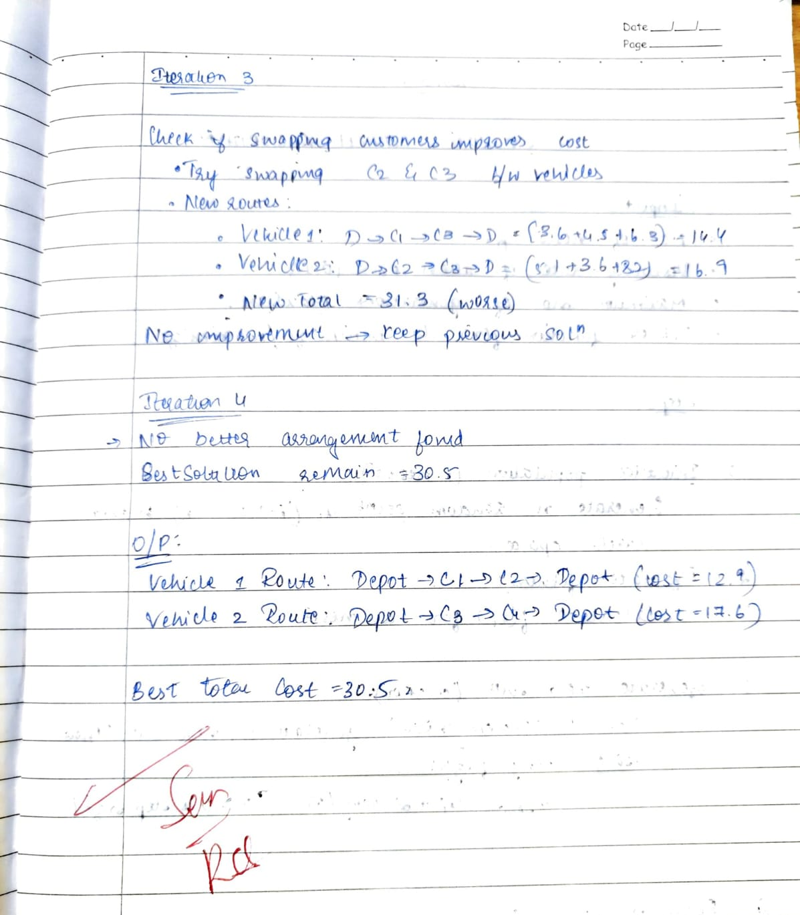
Code:
import random
import math

num_customers = 5
num_vehicles = 2
alpha = 1
beta = 3
rho = 0.5
Q = 100
num_ants = 8
iterations = 50

distances = [
[0, 2, 9, 10, 7, 3],
[2, 0, 8, 5, 6, 4],
[9, 8, 0, 7, 3, 6],
[10, 5, 7, 0, 4, 8],
[7, 6, 3, 4, 0, 5],
[3, 4, 6, 8, 5, 0]
]

pheromone = [[1 for _ in range(num_customers + 1)] for _ in range(num_customers + 1)]

def route_length(route):
return sum(distances[route[i]][route[i + 1]] for i in range(len(route) - 1))

def select_next_city(ant, visited):
current_city = ant[-1]
probs = []
for j in range(1, num_customers + 1):
if j not in visited:
tau = pheromone[current_city][j] ** alpha
eta = (1 / distances[current_city][j]) ** beta
probs.append((j, tau * eta))
total = sum(p[1] for p in probs)
r = random.random() * total
s = 0
for city, prob in probs:
s += prob
if s >= r:
return city
return probs[-1][0]

best_solution = None
best_total_cost = float('inf')

for _ in range(iterations):
all_routes = []
remaining_customers = list(range(1, num_customers + 1))
vehicle_routes = [[] for _ in range(num_vehicles)]
for v in range(num_vehicles):
ant_route = [0]
visited = []
while remaining_customers and len(ant_route)-1 < math.ceil(num_customers/num_vehicles):
next_city = select_next_city(ant_route, visited)
ant_route.append(next_city)
visited.append(next_city)
if next_city in remaining_customers:
remaining_customers.remove(next_city)
ant_route.append(0)
vehicle_routes[v] = ant_route
total_cost = sum(route_length(r) for r in vehicle_routes)
if total_cost < best_total_cost:
best_total_cost = total_cost
best_solution = vehicle_routes
for i in range(num_customers + 1):
for j in range(num_customers + 1):
pheromone[i][j] *= (1 - rho)
for route in vehicle_routes:
L = route_length(route)
for i in range(len(route)-1):
a, b = route[i], route[i+1]
pheromone[a][b] += Q / L
pheromone[b][a] += Q / L

for v, route in enumerate(best_solution, 1):
cost = route_length(route)
route_str = "->".join(f"C{i}" if i!=0 else "Depot" for i in route)
print(f"Vehicle {v}: Route: {route_str} (Cost={round(cost,2)})")
print(f"Best Total Cost: {round(best_total_cost,2)}")

Program 5
Cuckoo search algorithm

Algorithm:
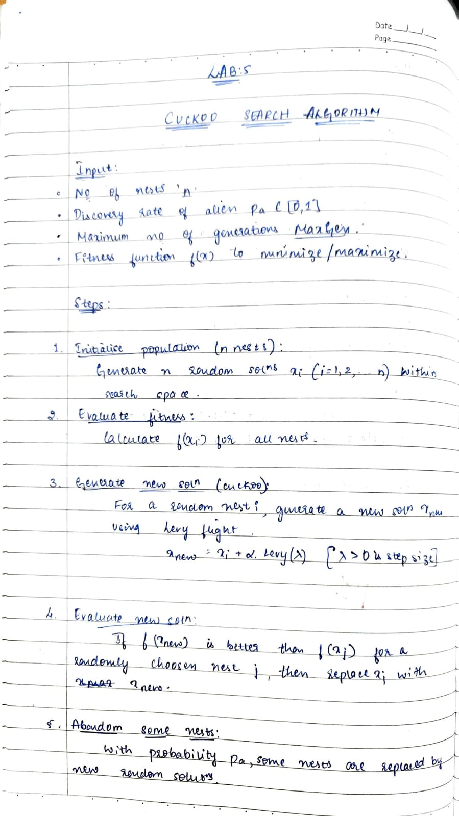
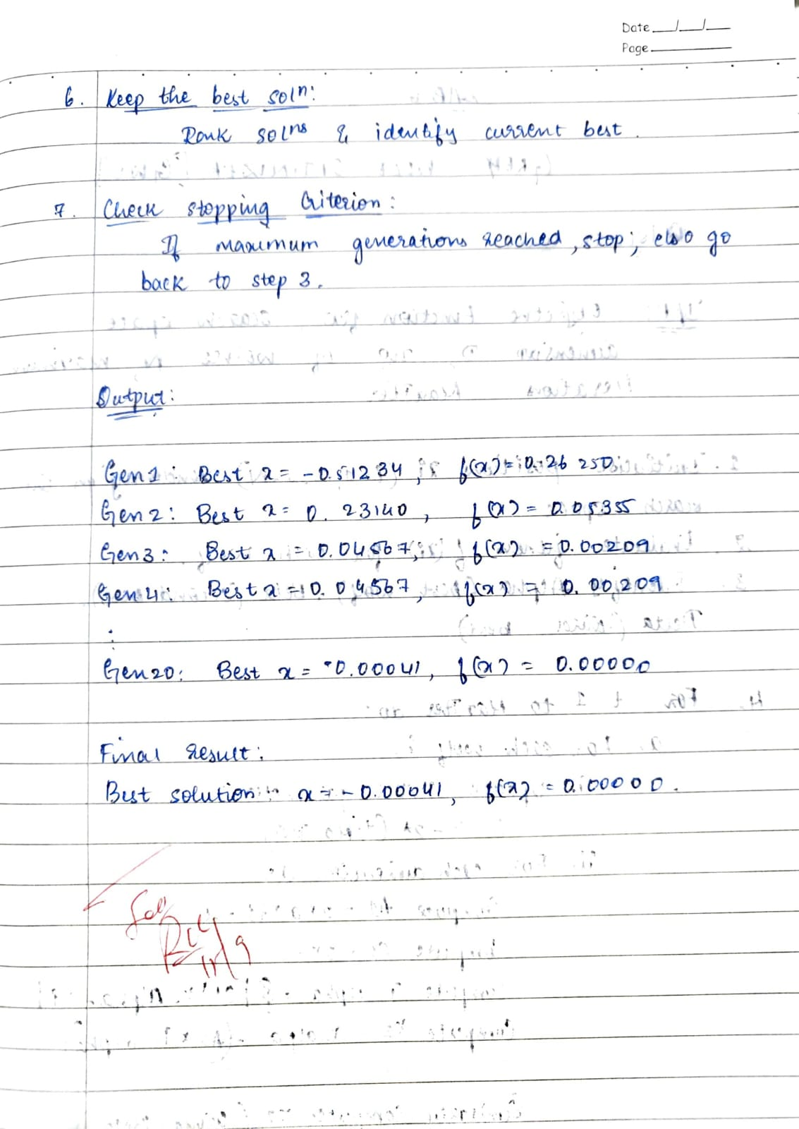
Code:
import random

def fitness(x):
return x**2

num_nests = 10
num_generations = 20
pa = 0.25
lb, ub = -10, 10

nests = [random.uniform(lb, ub) for _ in range(num_nests)]
best_nest = min(nests, key=fitness)

for gen in range(1, num_generations + 1):
for i in range(num_nests):
step_size = random.uniform(-1, 1)
new_nest = nests[i] + step_size
if new_nest < lb: new_nest = lb
if new_nest > ub: new_nest = ub
if fitness(new_nest) < fitness(nests[i]):
nests[i] = new_nest
for i in range(num_nests):
if random.random() < pa:
nests[i] = random.uniform(lb, ub)
current_best = min(nests, key=fitness)
if fitness(current_best) < fitness(best_nest):
best_nest = current_best
print(f"Generation {gen}: Best x = {round(best_nest,4)}, f(x) = {round(fitness(best_nest),4)}")

print("\nFinal Best Solution:")
print(f"x = {round(best_nest,4)}, f(x) = {round(fitness(best_nest),4)}")

Program 6
Grey wolf optimization algorithm

Algorithm:
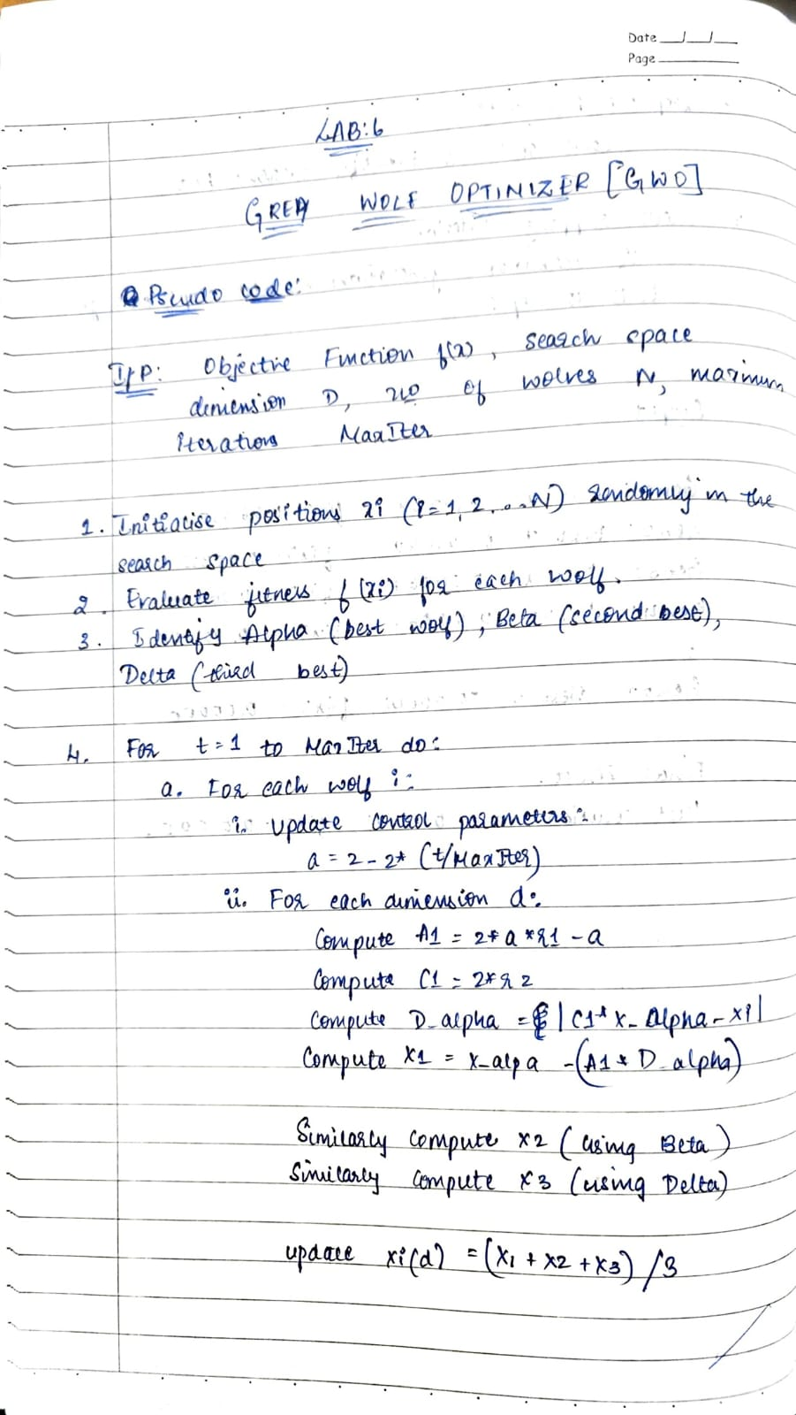
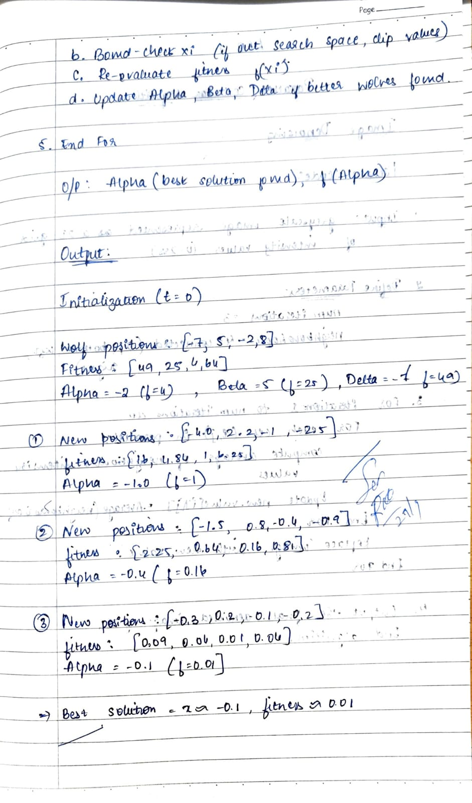
Code:
import random

def fitness(x):
return x**2

num_wolves = 5
num_generations = 5
lb, ub = -10, 10

wolves = [random.uniform(lb, ub) for _ in range(num_wolves)]

for gen in range(1, num_generations + 1):
fitnesses = [fitness(w) for w in wolves]
sorted_indices = sorted(range(num_wolves), key=lambda i: fitnesses[i])
alpha, beta, delta = wolves[sorted_indices[0]], wolves[sorted_indices[1]], wolves[sorted_indices[2]]

print(f"Generation {gen}:")
print(f"Wolf positions: {[round(w,4) for w in wolves]}")
print(f"Fitnesses: {[round(fitness(w),4) for w in wolves]}")
print(f"Alpha = {round(alpha,4)}, Beta = {round(beta,4)}, Delta = {round(delta,4)}\n")

for i in range(num_wolves):
r1 = random.random()
r2 = random.random()
A1 = 2 * r1 - 1
C1 = 2 * r2
D_alpha = abs(C1 * alpha - wolves[i])
X1 = alpha - A1 * D_alpha

r1 = random.random()
r2 = random.random()
A2 = 2 * r1 - 1
C2 = 2 * r2
D_beta = abs(C2 * beta - wolves[i])
X2 = beta - A2 * D_beta

r1 = random.random()
r2 = random.random()
A3 = 2 * r1 - 1
C3 = 2 * r2
D_delta = abs(C3 * delta - wolves[i])
X3 = delta - A3 * D_delta

wolves[i] = (X1 + X2 + X3) / 3
if wolves[i] < lb: wolves[i] = lb
if wolves[i] > ub: wolves[i] = ub

best_wolf = min(wolves, key=fitness)
print("Final Best Solution:")
print(f"Best x = {round(best_wolf,4)}, f(x) = {round(fitness(best_wolf),4)}")

Program 7
Implement image denoising using parallel cellular algorithm

Algorithm:
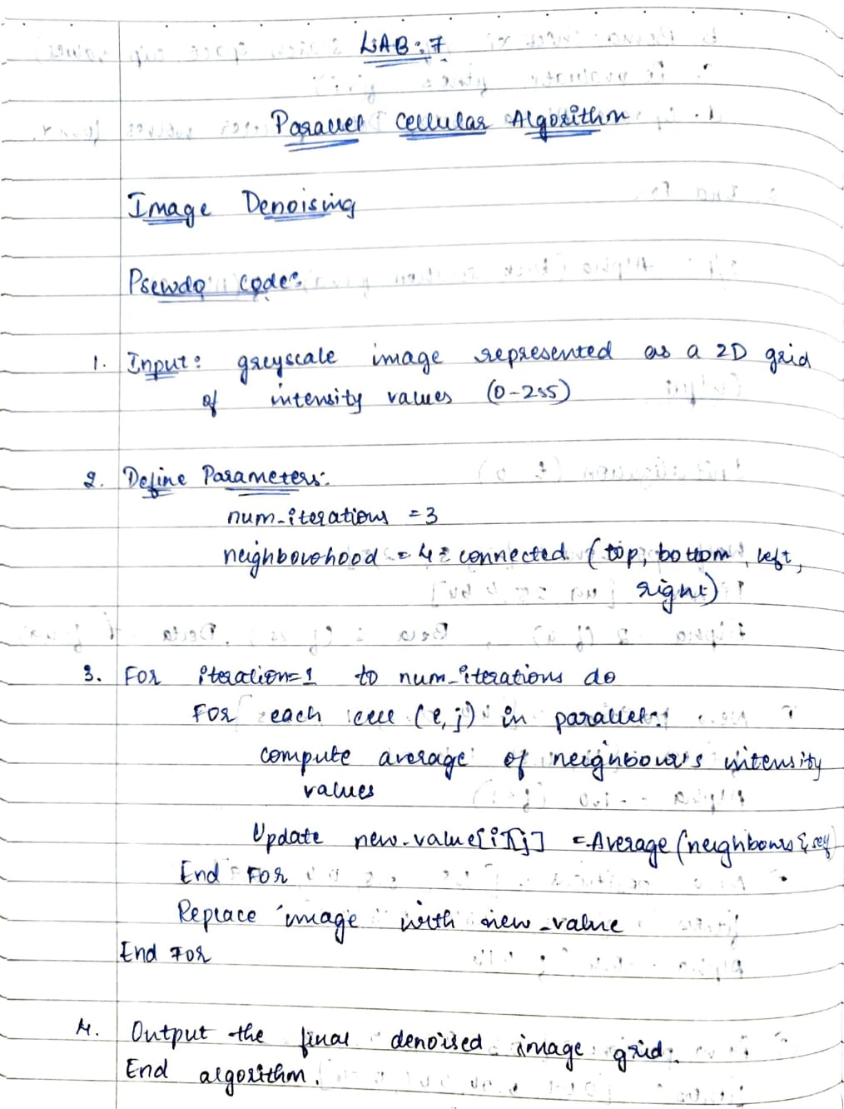
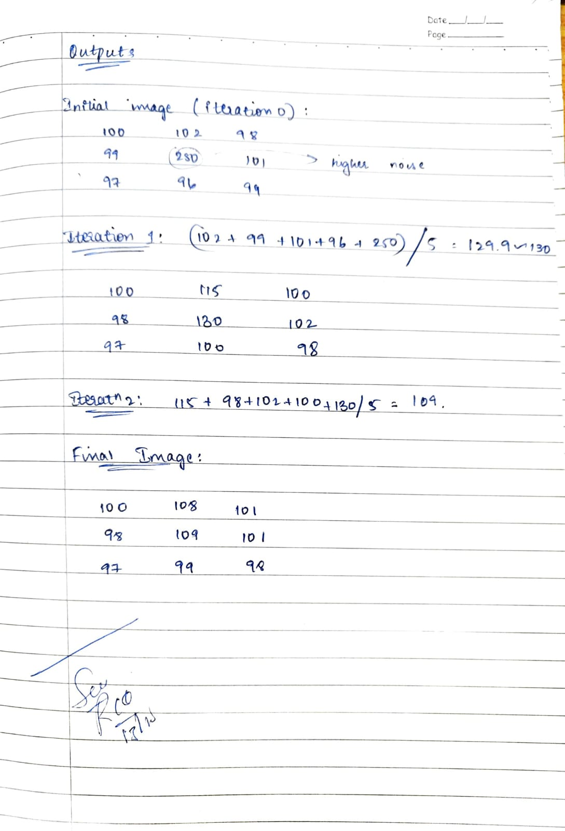
Code:
import numpy as np

def parallel_cellular_denoising(image, iterations=3):

image = np.array(image, dtype=float)
rows, cols = image.shape

print("Initial Image (Iteration 0):")
print(np.round(image, 2))
print("-" * 40)

for it in range(1, iterations + 1):
new_image = np.copy(image)

for i in range(rows):
for j in range(cols):
neighbors = [image[i][j]]

if i > 0:
neighbors.append(image[i - 1][j])

if i < rows - 1:
neighbors.append(image[i + 1][j])

if j > 0:
neighbors.append(image[i][j - 1])

if j < cols - 1:
neighbors.append(image[i][j + 1])

new_image[i][j] = sum(neighbors) / len(neighbors)

image = new_image

print(f"After Iteration {it}:")
print(np.round(image, 2))
print("-" * 40)

return np.round(image, 2)

noisy_image = [
[100, 102, 98],
[99, 250, 101],
[97, 96, 99]
]

final_image = parallel_cellular_denoising(noisy_image, iterations=3)

print("Final Denoised Image:")
print(final_image)

